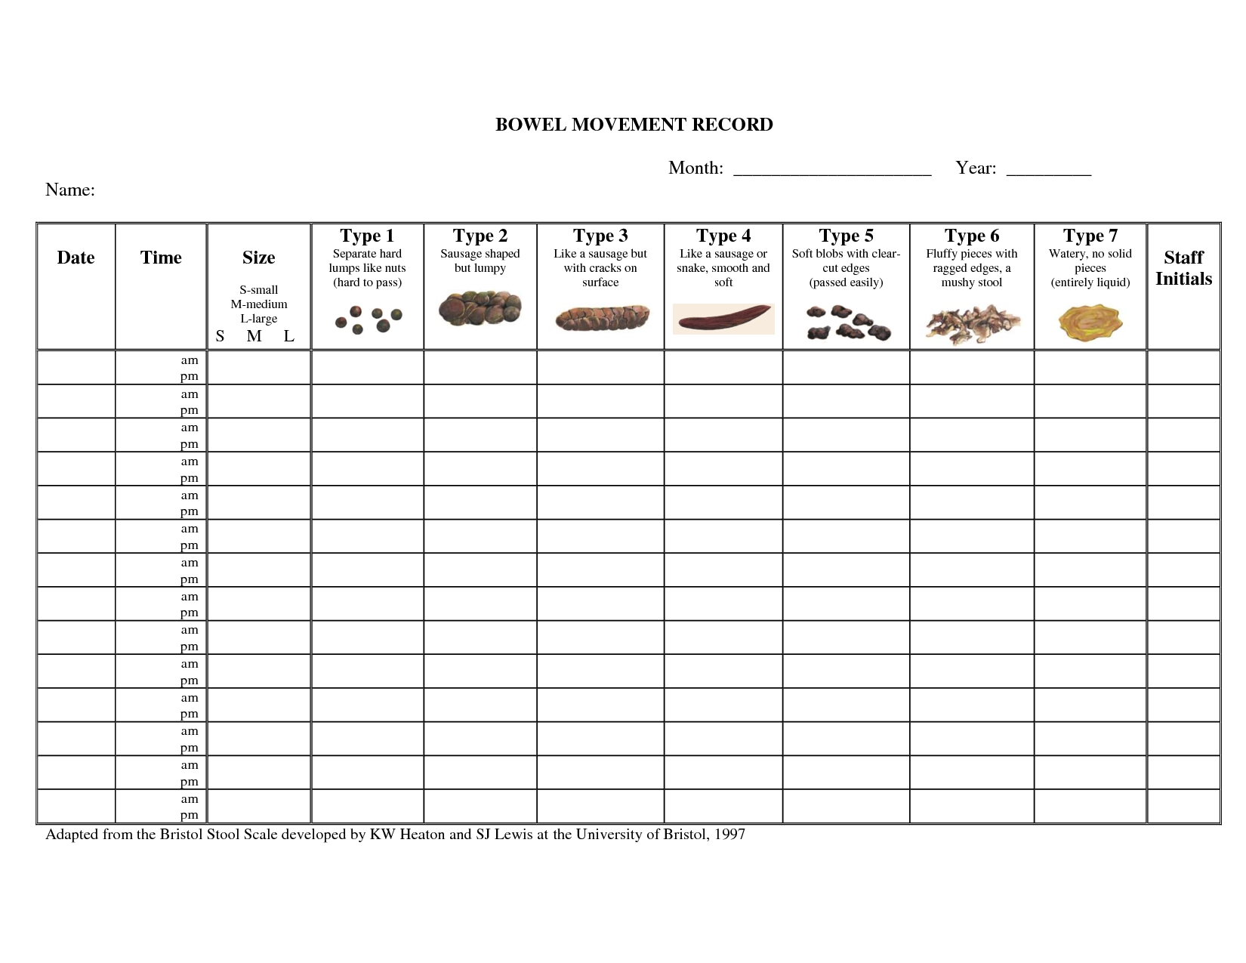
Was ‘as required’
(PRN) medication given?

