My Hospital Passport
Important information that hospital staff need to know
about me, my health and my support

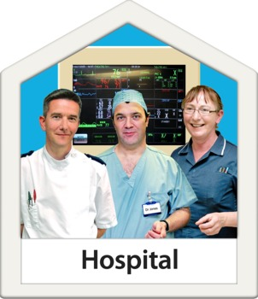

Things you need to know

Things that are important to me

My preferences

My Name:
Date completed:

Things you need to know about me
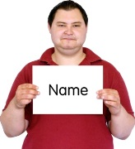 | Name:
 | I like to be known as:
 | NHS number:
 | Date of Birth:
 | Address:
 | Telephone number:
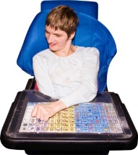 | How I communicate:
 | The language I speak/understand:
 | Family or support contact person:
 | Relationship to me:
 | Contact’s address:
 | Contact’s telephone number:
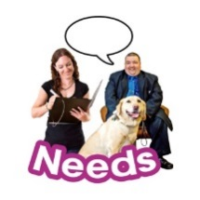 | A summary of my support needs:
 | My Religion:
 | My religious needs:
 | My ethnicity:
 | My G.P:
 | My G.P’s address:
 | My G.P telephone number:
 | Other professionals that are involved in my support and care:
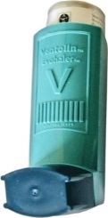 | Allergies:
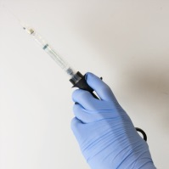 | Medical interventions (how to take my blood, take blood pressure, give injections, etc…):
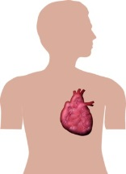 | Important information about my heart:
 | Important information my breathing:
 | Any risk of choking (eating, drinking, swallowing…):
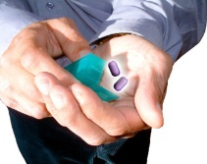 | Current medication:
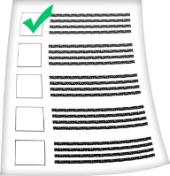 | My medical history/treatment plans:
 | What you must do if I’m anxious or upset:

Things that are important to me
 | How you must communicate with me:
 | How I take my medication: -
 | How you know I am in pain:
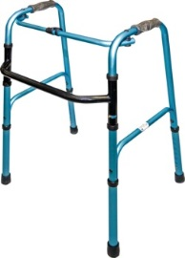 | Moving around (posture in bed, walking aids):
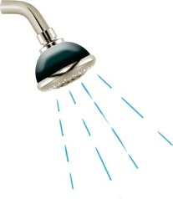 | Personal care- Dressing/ Washing etc
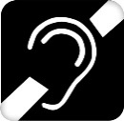  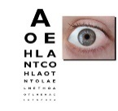 | Seeing/hearing-
 | How I eat (preferences, issues with choking, etc.):
 | How I drink:
 | How I keep safe (behaviour, bed rails…):
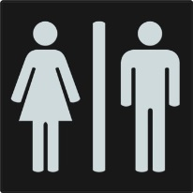 | How I use the toilet (incontinence, support using the toilet):
 | How and when I like to sleep:
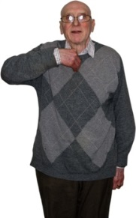 | Other things that are important to me:

My Preferences
Things that work for me or that I like such as: watching TV, listening to the radio, sitting up in bed, talking about sport, joking around…

And things that don’t work for me or that I don’t like such as: certain types of food, people shouting, being touched, too much noisy chat…
Things that work for me or that I like | And things that don’t work for me or that I don’t like

