I’m going to play a video game

My name is ________________________

I am going to play a video game at the Game store in Preston.
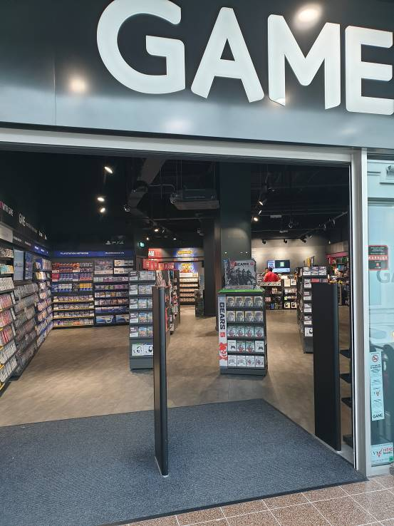

There is part of the Game store in Preston that has computers, consoles and screens.
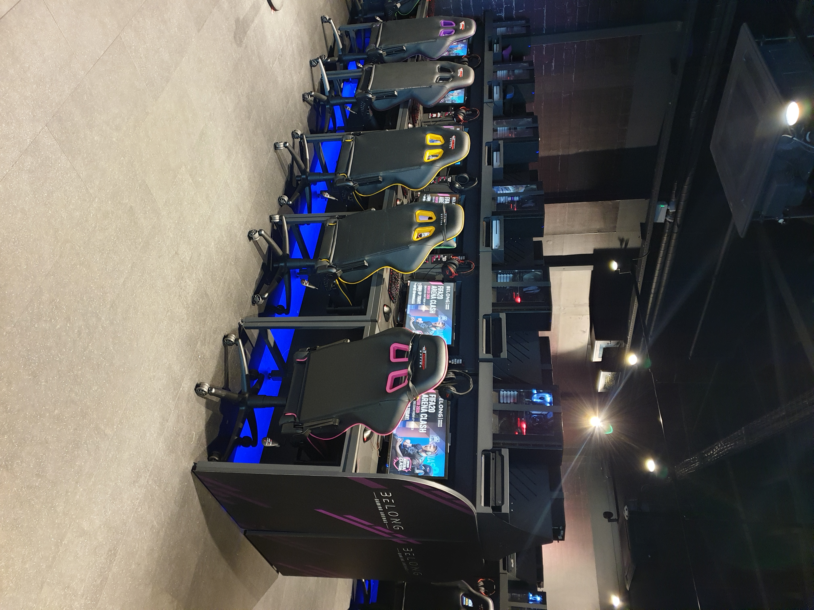

This part of the Game store is called the Belong Arena.

There are adjustments at the Belong Arena to help make it autism friendly.

The staff at the Belong Arena are trained in autism awareness.

The staff are there to help me feel comfortable and safe, and to have a good time.

My trip to the Belong Arena

I will set off to go to the Game store in Preston at _______ on _______________________

I have a computer booked at the Game store for ________ __________________

I have booked to play ______________________________

To get to the GAME Store I will go to the St George’s Centre and up the escalators.
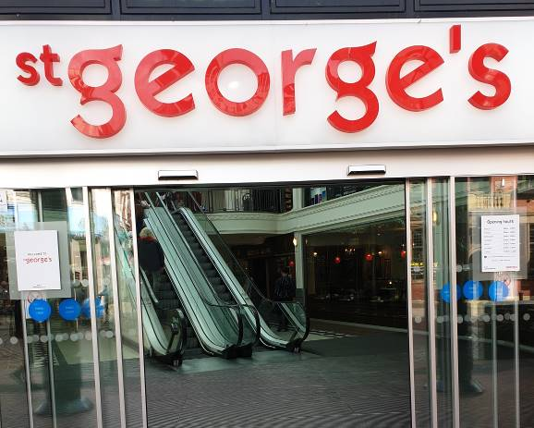
When I arrive at the Game store I will walk to the Belong Arena.

The Belong Arena is on the right after I enter the GAME store.

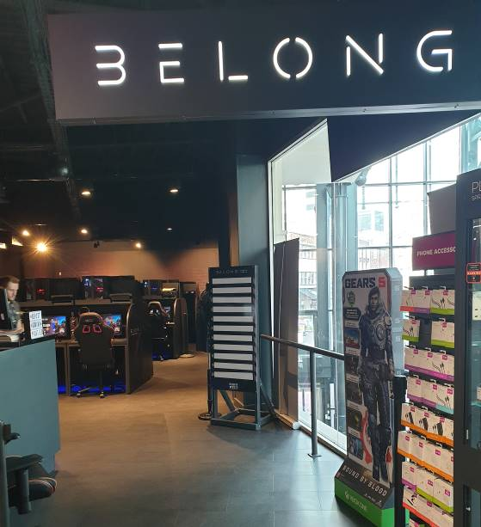

When I am in the Belong Arena I will wait there and a member of staff will come to help me.

I will tell them my name and they will show me which computer I am going to use.

If I don't like where the computer is I can tell them. This is ok and, if it is possible to, they will help me find somewhere I prefer.

When I am sat at the computer

When I am sat at a computer the member of staff will make sure the game I chose is ready to play.

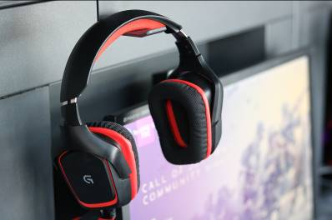

I will need to wear headphones and the member of staff will help me put them on.

They might have to touch me to do this but they will ask me first. If I do not want this they will explain how I can do it myself.

There might be other people in the Belong Arena playing games too. This is ok and they will have headphones on.

When I am playing the game

The member of staff will leave and I will play the game.

A member of staff might come back to ask how I am. I can answer and talk to them. Or I can nod yes or shake my head no.

If I am not happy with anything I can tell a member of staff. This is ok and they will try to help.

Other customers might make noise. This is ok. If it gets too loud and I don't like it I can tell a member of staff and they will try to help.

The people next to me might not want to talk. This is ok.

If I need the toilet I can ask a member of staff.

Before 6pm I can use the toilets in the St George's Centre.

After 6pm I can use the toilets in the Belong Arena.
When my time to play the game will run out soon a member of staff will warn me.

When my time to play the game has ran out a member of staff will tell me.

I will collect my things and leave the store.

