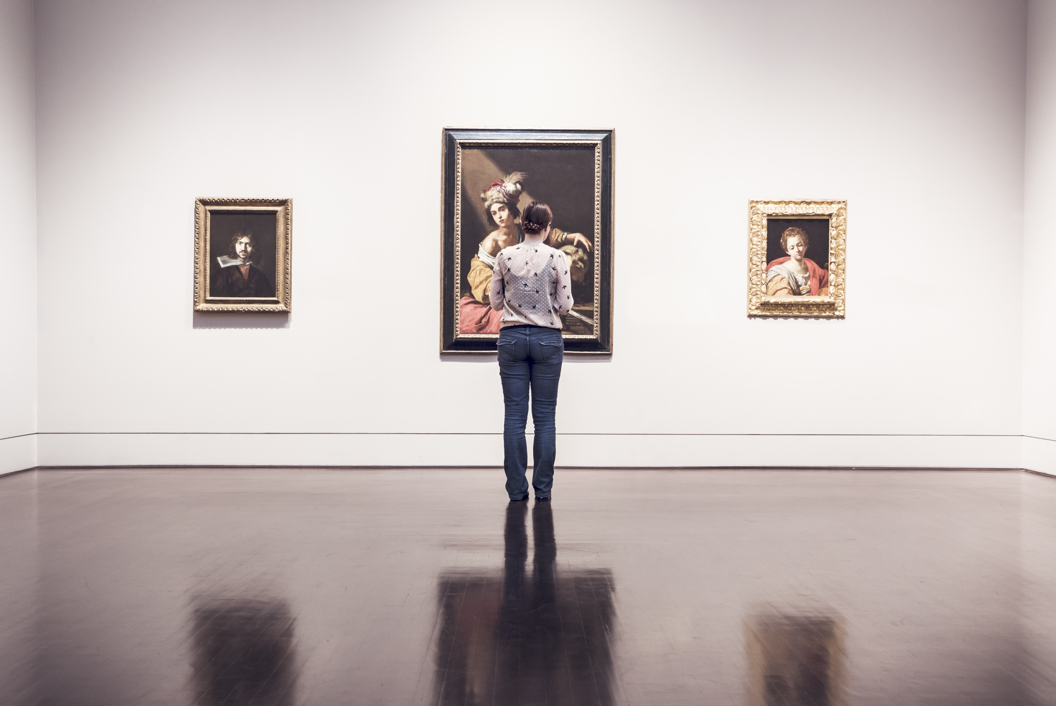

**Some of our visitors might make noises.**

**This helps them cope with stress.**

**Talk to a member of staff to find out more.**

**This museum is autism friendly**

**dimensions-uk.org/autismmuseums**