‘Save our social care’: equal pay petition, backed by over 76,000 people, handed into No.10 Downing Street

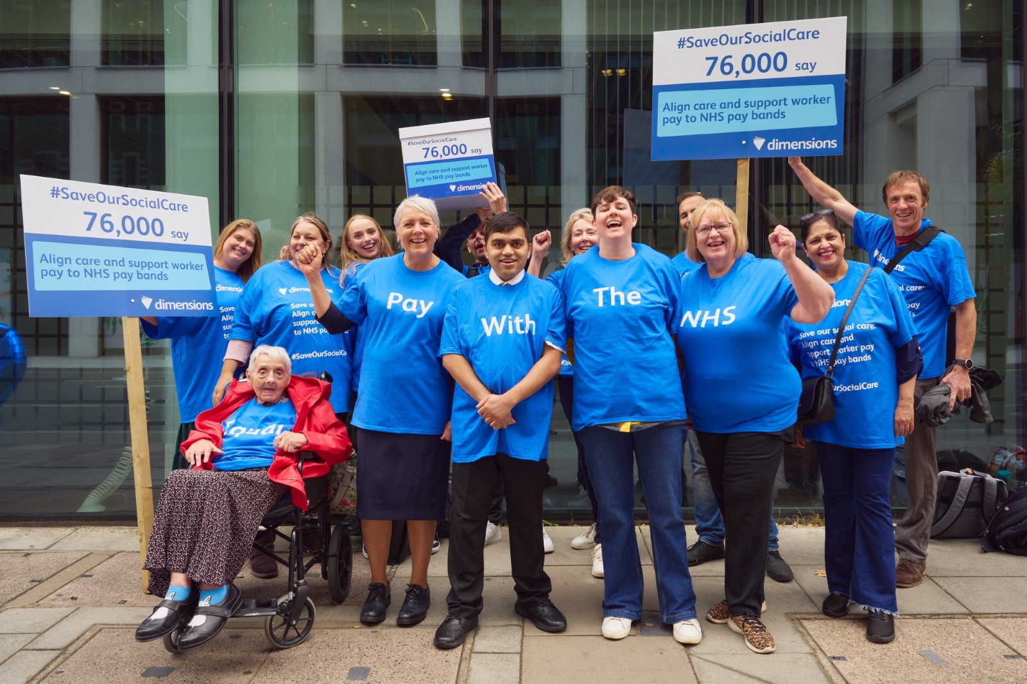
Dimensions team ahead of the petition hand-in

On Tuesday 19th September, not-for-profit support provider Dimensions led a cross-party march to No.10 Downing Street to hand in its petition calling for government to align minimum care worker pay to NHS Band 3 – a plea supported by over 76,000 members of the public.

Damian Green MP, Paul Blomfield, Labour MP and Zack Polanski, Deputy Leader of the Green Party, joined Dimensions’ Chief Executive Rachael Dodgson, support workers, people supported and members of the Dimensions Council to deliver the petition and urge government to give social care the recognition it so urgently needs.

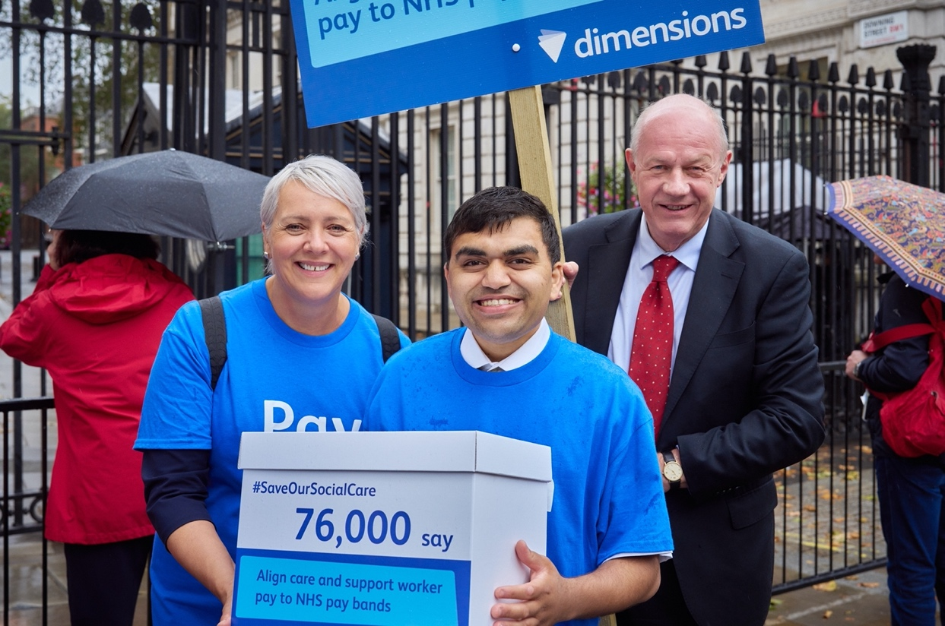

Damian Green pictured with Rachael Dodgson, and a person with lived experience

Across the UK, care and support workers are earning below the Real Living Wage. Meanwhile, In the past three years, a typical sales assistant has gone from earning 13 pence per hour less than a care and support worker to 21p more. This shift is having a huge impact on people's career choices. Low pay is driving people out of essential careers in social care, leading to around 152,000 social care vacancies today¹, with many people who require social care not receiving it.

After years of delayed reform, urgent action is needed to prioritise recruitment and retention and encourage a pool of dedicated workers into social care careers for the long-term. In Scotland, the First Minister has recently announced that social care staff will receive at least £12 an hour from April 2024², but the rest of the UK is yet to follow suit.

Dimensions’ petition launched in May this year, alongside research showing that 80% of the public think social care is as important or deserves the same respect as the NHS. NHS Band 3 includes clinical support workers, therapy assistants, pharmacy assistants, administrative workers, and clerical staff, who are currently paid £11.67 per hour. The vast support for the petition reflects the belief that social care workers’ skills and professionalism should be recognised at an equal level with these important roles.

Rachael Dodgson, Chief Executive of Dimensions, says:
“It is incredibly encouraging to see the country unite behind our cause and recognise the vast importance of our social care workforce and the difference they make to the people they support.

“Every day, thousands of social care and support workers undertake complex delegated nursing tasks and support people to make choices and gain control over their life. They maintain family relationships, help with friendships, support with employment and personal care. They are skilled, professional workers.”

“While other sectors have seen pay rise after pay rise, social care has been left behind. If this continues for much longer, not only will the people who rely on our support be impacted, but the NHS will also slow to a halt.

“Increasing social care pay isn’t just a case of rewarding hard work, but will support recruitment and retention efforts at a time when the sector is under immense pressure. We urge the government to consider our call and move social care funding up the agenda.”

Rt Hon Damian Green, Conservative MP for Ashford and co-chair of the Adult Social Care APPG, says:
“The social care crisis has been escalating for decades and becomes ever more urgent to address by the day. Dimensions’ petition calls for an essential change that I believe will go a long way towards preventing skilled social care workers from leaving the workforce for better paid roles elsewhere. We cannot fix the NHS without addressing the problem in social care first, and increasing pay to attract more staff is one key element of this.”

Paul Blomfield, Labour MP for Sheffield Central and member of the Health and Social Care Committee, says:
“The government mustn’t shirk responsibility for social care staff any longer. They set the funding for the sector and by cutting local councils have held down wages, undervaluing care workers and creating a staffing crisis. We need to align care wages with the NHS recognising its dependence on social care”

Susan Adewale, 35, a Relief Support Worker for Dimensions, says:
“I adore working for an organisation which is committed to making a positive difference in people’s lives. I have witnessed first-hand the transformative power of social care and its profound impact on individuals and their families. The opportunity to make a meaningful difference, no matter how small, fuels my enthusiasm every day.

“But I hold a firm belief that social care workers should be paid in line with the NHS Pay Band 3. Not only do our tireless efforts and unwavering commitment warrant pay parity, but it would elevate the status of social care, allowing us to support the NHS more effectively and ensuring that the remarkable work we do continues to flourish.”

To build on the petition’s momentum and continue pushing for change, Dimensions will host a Parliamentary reception in the House of Commons on 4th December. It will bring together parliamentarians, industry experts, social care providers and support workers to discuss the necessary steps to help employers to recruit and retain social care workers.

The petition is still open. To sign, please visit: http://www.change.org/social-care-pay

ENDS

Please find photos from the petition hand-in here: https://www.dropbox.com/sh/a16bztudi1hma4b/AAABmxzRaWmuN1mZL4UdtdbZa?dl=0

At the time of writing, the petition has 76,460 signatures.

Notes to editors
For more information, interviews, and case studies, please contact:

Kitty Grenham: kitty@standagency.com | dimensions@standagency.com
Beth Davies: beth@standagency.com | dimensions@standagency.com

About the research
In April 2023, Censuswide surveyed 2,001 adults across the UK, on behalf of Dimensions.

About Dimensions
Dimensions provides evidence-based, outcomes-focused support for people with learning disabilities, autism and complex needs. We help people be actively involved in their communities.

We are one of the largest not-for-profit support providers in the UK. We currently support around 3,500 people and their families throughout England and Wales with help from our 7,000 members of staff.

We have been providing support packages for families for 40 years. We offer a range of support services to adults of all ages, including those with complex needs or challenging behaviour.

We are proud to be a not-for-profit organisation, not here for commercial gain. This means we’re able to invest all our efforts and resources into the important things – which is helping the people we support lead happy and fulfilled lives.
Comments from the ‘Save our Social Care’ petition signatories:

“My son is completely dependent on his carers. They give him quality of life and keep him safe. Without them he would not be able to live at all. Social care workers are crucial, important and highly valued members of society. The person who helps me keep my house clean gets above minimum wage. The people who look after my most precious son should be paid so much more. Time to end this disgraceful injustice.” – Susan Dawson

“How can such an important role not be given the recognition it deserves? People are being paid 2003 wages for 2023 work, it makes no sense and has to stop now.” – A R R

“The work of care and support workers is easily as important as nursing work and good care packages keep people from ending up in the kind of crises that put more pressure on hospitals. For decades there has been a need to value the people working in this vital career and attract the highest calibre candidates” – Polly Oliver

“I wonder, other than the NHS, who else deals with such potential stress and challenges in one shift? If we don't do anything now, there will be nobody left to support your loved one in the future.” – Lesley Brown

Case studies:

Ben Spencer
Ben Spencer, 36, is a Support Worker for Dimensions working in Worcestershire. He began his journey into the social care sector so he could understand more about his own autism. Dimensions has been supportive in making adaptations to allow him to be the best Support Worker he can be, and for that reason, Ben has been able to thrive in his career.

He thoroughly enjoys every day and says “I enjoy my role because my colleagues are always striving to help and always open to other people’s views to improve our work. This means we’re able to do our best to support people with learning disabilities and autism to enjoy their life how they want to.”

Ben strongly supports Dimensions’ petition to align support worker pay to NHS Band 3 to prevent people being forced out of this rewarding career because of the low salary and cost-of-living concerns.

“I personally believe that support workers deserve parity of pay with the NHS. We all work tirelessly to make sure the people we support are safe and to provide them with the care they need to help achieve their goals, but we’re often treated as an afterthought by policymakers. I love my job and would encourage others to sign up, but I’m aware that the low pay is acting as a barrier and needs to be addressed.”

+++

Susan Adewale
Susan Adewale, 35, is a Relief Support Worker in Newcastle who has found immense fulfilment in her work. “I adore working for an organisation which is committed to making a positive difference in people’s lives. I have witnessed first-hand the transformative power of social care and its profound impact on individuals and their families. The opportunity to make a meaningful difference, no matter how small, fuels my enthusiasm every day.”

But she knows that many people won’t be able to enjoy the rewards of social care careers, because they simply can’t afford to live on the salary. Susan hopes that sharing her experiences will inspire others and ignite change. She recognises that not only would increased pay signal the value of social care, but also attract talented individuals to join the field, ultimately benefiting the people that rely on their support.

“I hold a firm belief that social care workers should be paid in line with the NHS Pay Band 3. Not only do our tireless efforts and unwavering commitment warrant pay parity, but it would elevate the status of social care, allowing us to support the NHS more effectively and ensuring that the remarkable work we do continues to flourish.”

+++

Jorden Carter
Jorden is a Lead Support Worker at Dimensions. Jorden’s mum has worked in the social care sector since Jorden was three, so she grew up seeing the rewards and challenges of the job. In 2018 Jorden decided to follow in her mum’s footsteps, and work at the same location that her mum started in. She moved to a Dimensions location in April 2022.

As a Lead Support Worker, Jorden’s day-to-day responsibilities include medication distribution, personal care, mealtime assistance, and supporting people to go out and about in the community, along with a host of other things – no day is ever the same!

She loves working with those she supports to “help them live as independently possible, helping them to do and enjoy the activities we all love.” She says, “the people you support make it all worthwhile.”

Throughout her career in social care, she has experienced belittling labels such as ‘glorified bum wiper’ and feels that people often lack an understanding of the value of support workers. She says “we know the people we support, we are a big part of their lives, we understand their needs, both medical and emotional.”

With regards to pay, Jorden feels that there is limited recognition for how much training and work support workers do. It’s a rewarding job and one that she does because she loves it, but to read that you can earn more in the NHS, retail and hospitality is disheartening.

